CHAPTER 4

SYSTEM DEVELOPMENT, IMPLEMENTATION, TESTING, EVALUATION, RESULTS, AND DISCUSSION

4.2 OVERVIEW OF THE DEVELOPED SYSTEM
The Web-Based Membership Management System: Member Records, Registration, and Fee Tracking is a web-based information system developed to automate and improve the organization's membership management processes. The system serves as a centralized platform that enables authorized personnel to efficiently manage member information, process membership registrations, monitor membership fee payments, and generate reports necessary for organizational operations. By replacing the organization's existing manual procedures with a computerized system, the application provides a faster, more accurate, and more reliable approach to managing organizational records.
The developed system addresses the common challenges associated with manual membership management, including inaccurate record keeping, duplicate member information, delayed registration processing, difficulty in monitoring membership fee payments, and the time-consuming preparation of reports. Through automation, the system minimizes human errors, improves data consistency, and enhances the overall efficiency of administrative operations.
The application provides a secure user authentication mechanism that allows only authorized users to access the system. Depending on the assigned user role, administrators and staff members are granted appropriate access privileges to perform their designated responsibilities. This security feature helps maintain the confidentiality, integrity, and availability of organizational data while preventing unauthorized access to sensitive member information.
The module enables staff members to record and process new member applications electronically. During registration, the system captures essential member information, including personal details, contact information, membership category, and registration date. All submitted records are stored in a centralized database, allowing authorized personnel to retrieve, update, or verify member information whenever necessary.
The Member Records Management module serves as the primary repository of all registered members. It provides functions for creating, viewing, updating, searching, and maintaining member profiles. The module allows administrators and authorized staff to efficiently organize member records while ensuring that information remains accurate, complete, and up to date.
Advanced search and filtering functions further simplify the retrieval of specific records, particularly when managing a large number of members.
The Membership Fee Tracking module allows authorized users to monitor and record membership fee payments. Each payment transaction is linked to the corresponding member account, enabling the organization to maintain an accurate payment history for every registered member. The system automatically updates payment records after each transaction, making it easier to determine whether a member has paid, has outstanding balances, or requires payment reminders. This functionality significantly reduces the possibility of recording errors commonly encountered in manual payment monitoring.
To support organizational decision-making, the system includes a Reports Generation module capable of producing comprehensive reports related to membership registration, active members, membership fee collections, payment histories, and other relevant organizational records. These reports can be generated whenever needed, providing administrators with timely and accurate information for monitoring organizational performance and supporting administrative planning.
The developed application utilizes a centralized relational database that securely stores all system information, including user accounts, member profiles, registration records, membership fee transactions, and payment histories. The use of a centralized database ensures data consistency, minimizes redundancy, and facilitates efficient retrieval of information across different system modules.
The system was developed using modern web technologies suitable for database-driven applications. The user interface was designed to be simple, responsive, and easy to navigate, allowing users with varying levels of computer proficiency to operate the system with minimal training. Proper input validation, authentication mechanisms, and database security measures were incorporated to maintain the integrity and confidentiality of organizational data.
Overall, the Web-Based Membership Management System provides a practical and efficient solution for managing membership information, registration activities, and membership fee monitoring within the organization. By automating routine administrative tasks and centralizing organizational records, the developed system improves operational efficiency, enhances data accuracy, strengthens information security, and supports faster decision-making. The implementation of the system demonstrates how information technology can significantly improve organizational processes through the digital transformation of traditional membership management practices.
The major objectives of the developed system are as follows:
- To automate the registration of new members through an electronic registration process.
- To maintain a centralized database for storing and managing member records.
- To record, monitor, and update membership fee payments efficiently.
- To minimize errors associated with manual record keeping and payment tracking.
- To provide secure user authentication and role-based access control.
- To generate accurate and timely reports related to membership and fee transactions.
- To improve the efficiency, accuracy, and reliability of membership management operations.
- To support organizational decision-making through organized and accessible information.
The development of the Web-Based Membership Management System follows established software engineering principles by integrating responsive web technologies, secure database management, user authentication, role-based access control, and reliable information processing. These features collectively contribute to a system that effectively addresses the organization's membership management requirements while providing a scalable and maintainable solution for future organizational growth.

4.3 SYSTEM DEVELOPMENT METHODOLOGY
The development of the Web-Based Membership Management System: Member Records, Registration, and Fee Tracking adopted the Agile Software Development Methodology, an iterative and flexible software development approach that emphasizes continuous collaboration, incremental development, and regular evaluation throughout the Software Development Life Cycle (SDLC). The Agile methodology was selected because it allows the development team to respond effectively to changing user requirements while ensuring that the developed system continuously meets the operational needs of the organization.
Unlike traditional software development models that complete each phase only once, Agile divides the project into smaller development cycles known as iterations or sprints. At the end of every sprint, a functional component of the system is produced, evaluated, and improved based on user feedback before the next development cycle begins. This iterative approach enabled the researchers to identify system issues at an early stage, implement necessary improvements, and ensure that each module functioned according to the specified requirements.
Throughout the development process, regular communication was maintained between the researchers and the intended users to validate system requirements, verify completed functionalities, and obtain recommendations for improvement. This collaborative approach ensured that the final system effectively addressed the organization's membership management needs while maintaining usability, reliability, and data accuracy.
The development of the system consisted of the following phases:

Requirements Gathering
The initial phase involved gathering information necessary for the development of the proposed system. The researchers conducted interviews, observations, and document analysis to understand the organization's existing membership management procedures. Information regarding member registration, record management, membership fee collection, report preparation, and user responsibilities was collected to identify the problems encountered in the manual process.
The gathered information was analyzed to determine both the functional and non-functional requirements of the system. Functional requirements included user authentication, member registration, member record management, membership fee tracking, payment recording, report generation, and user account management. Non-functional requirements focused on system security, usability, reliability, performance, and database integrity.
System Planning
Following the requirements gathering phase, the researchers established the overall project scope, objectives, development schedule, resource allocation, and technical specifications required for the successful completion of the project. During this phase, the feasibility of developing the proposed system was carefully evaluated from technical, operational, and economic perspectives.
The planning stage also included identifying the software development tools, programming languages, database management system, hardware requirements, and implementation strategies that would be used throughout the project. A project timeline was prepared to monitor the progress of each development activity and ensure that project milestones were completed within the scheduled timeframe.
System Design
During the design phase, the overall structure and architecture of the system were carefully planned. The researchers designed the database structure, user interface layouts, process `workflows, and system modules that would serve as the blueprint for system development.
Several system modeling tools were utilized during this phase, including the Use Case Diagram, Activity Diagram, Sequence Diagram, Class Diagram, Deployment Diagram, System Architecture Diagram, Data Flow Diagram (DFD), and Entity Relationship Diagram (ERD). These diagrams provided a visual representation of the system's processes, user interactions, data flow, and database relationships, ensuring that all functional requirements identified during the analysis stage were properly incorporated into the system design.

The user interface was also designed with emphasis on simplicity, consistency, and ease of use to provide an efficient working environment for administrators and staff members.
Software Development
After completing the system design, the researchers proceeded with the actual implementation of the application. The system was developed using modern web development technologies, including PHP as the server-side programming language, HTML, CSS, Bootstrap, and JavaScript for the user interface, while MySQL served as the relational database management system. The application was developed and tested using the XAMPP local server environment.
Each system module was implemented incrementally following the Agile methodology. Core functionalities such as user authentication, member registration, member records management, membership fee tracking, payment management, report generation, and user account administration were developed, tested, and refined before proceeding to the next module. This incremental approach allowed the researchers to detect programming errors early and continuously improve the quality of the application.
Testing
Upon completion of each module, various software testing activities were conducted to verify that the developed functionalities operated correctly. Individual modules first underwent unit testing to validate their specific functions independently. Once verified, the modules were integrated into the complete application, where integration testing was performed to ensure proper communication and interaction among all system components.
The fully integrated system then underwent system testing to evaluate its overall functionality, performance, reliability, and security. The researchers verified that each feature satisfied the identified functional requirements and that the application consistently produced accurate results under normal operating conditions.
Finally, User Acceptance Testing (UAT) was conducted with selected users from the organization. Participants evaluated the system based on usability, functionality, reliability, efficiency, and overall user satisfaction. Feedback obtained during this stage served as the basis for implementing final refinements before system deployment.
Deployment
After successfully completing all testing procedures, the developed system was deployed within the organization's operating environment. Deployment involved configuring the local web server, importing the MySQL database, installing the application files, and establishing user accounts for authorized administrators and staff members.

The researchers ensured that all necessary configurations were properly completed before the system became operational. Existing member records and payment information, when available, were encoded into the database to facilitate a smooth transition from the manual process to the computerized system. Authorized users were also provided with basic orientation and guidance regarding the operation of the developed application.
Maintenance
The final phase of the Agile Software Development Methodology involves maintaining the developed application after deployment. Maintenance activities include monitoring system performance, correcting identified errors, improving existing functionalities, implementing software updates, and enhancing system security whenever necessary.
As organizational requirements continue to evolve, additional features may be incorporated into the system to further improve its functionality and efficiency. Regular database maintenance, system backups, and software updates are also recommended to ensure the long-term reliability, security, and continuous availability of the Web-Based Membership Management System.
Figure 4.2 illustrates the Agile Software Development Life Cycle adopted in the development of the Web-Based Membership Management System: Member Records, Registration, and Fee Tracking.

4.4 SYSTEM ARCHITECTURE
The Web-Based Membership Management System: Member Records, Registration, and Fee Tracking utilizes a Three-Tier Client-Server Architecture, which separates the presentation layer, application layer, and data layer into independent components. This architectural approach enhances the system's maintainability, scalability, security, and overall performance by assigning specific responsibilities to each layer. Through this architecture, user requests are processed efficiently while ensuring secure communication between the application and the database.
The system architecture enables authorized users to access the application through a web browser connected to a local area network or the Internet, depending on the deployment environment. User requests are first received by the presentation layer, processed by the application layer, and then stored or retrieved from the centralized database located in the data layer. This separation of responsibilities improves system organization, simplifies maintenance, and facilitates future enhancements without significantly affecting other components of the application.w`
Figure 4.3 illustrates the system architecture of the developed Web-Based Membership Management System.
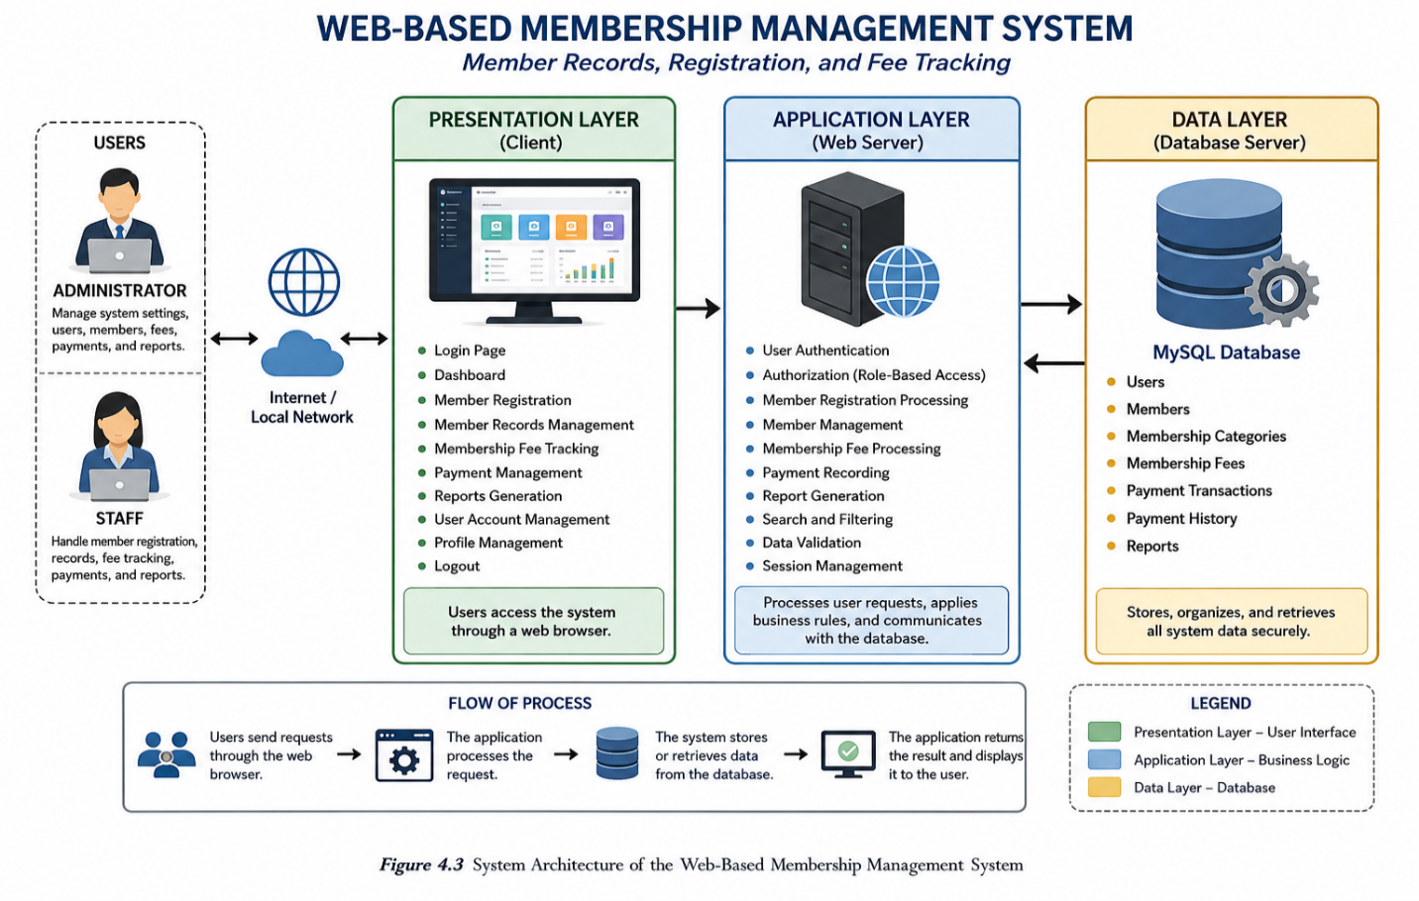The architecture consists of the following major components;

Presentation Layer
The presentation layer serves as the interface between the users and the application. It is responsible for displaying information, receiving user inputs, and providing access to the various system functions through a user-friendly graphical interface. This layer allows administrators and authorized staff members to interact with the system using desktop computers, laptops, tablets, or other devices capable of accessing a modern web browser.
The user interface was designed to provide a simple, consistent, and responsive environment that enables users to perform their assigned tasks efficiently with minimal training. Appropriate validation messages, navigation menus, and interactive forms were incorporated to improve usability and reduce user errors during system operation.
The major interface components include:
- Login Page
- Dashboard
- Member Registration
- Member Records Management
- Membership Fee Tracking
- Payment Management
- Report Generation
- User Account Management
- Profile Management
- Logout Function

Application Layer
The application layer contains the business logic of the system. It is responsible for processing user requests, validating input data, enforcing system rules, communicating with the database, and generating the appropriate responses displayed in the user interface.
Whenever a user performs an operation, such as registering a new member, updating member information, recording a membership fee payment, or generating reports, the application layer processes the request according to the defined business rules before storing or retrieving data from the database. This layer also performs input validation, user authentication, session management, and role-based access control to ensure that only authorized users can perform specific operations.

The primary responsibilities of the application layer include:
- User Authentication
- User Authorization
- Session Management
- Member Registration Processing
- Member Records Management
- Membership Fee Processing
- Payment Recording
- Data Validation
- Report Generation
- Dashboard Processing
- Search and Filtering Functions
The application server acts as the intermediary between the presentation layer and the database server, ensuring that all transactions are securely processed before data is stored or retrieved.

Data Layer
The data layer serves as the centralized repository of all information managed by the system. It is implemented using a relational database management system that stores organizational data securely while maintaining data consistency and integrity through primary keys, foreign keys, and relational constraints.
The database is responsible for organizing, storing, updating, and retrieving records required by different modules of the application. Since all information is maintained within a centralized database, authorized users can access accurate and up-to-date records whenever necessary.
The data layer stores information related to:
- User Accounts
- Member Information
- Membership Registration Records
- Membership Categories
- Membership Fee Records
- Payment Transactions
- Payment History
- System Reports
Database normalization techniques were applied during database design to reduce data redundancy and maintain consistency among related tables. Proper indexing and relational constraints further improve the efficiency of data retrieval while preserving the integrity of stored information.

The communication between the application layer and the data layer is protected through authentication mechanisms and controlled database access. Only validated system requests are permitted to interact with the database, thereby preventing unauthorized access and maintaining the confidentiality of sensitive organizational records.
Overall, the Three-Tier Client-Server Architecture provides a reliable foundation for the Web-Based Membership Management System. The separation of the presentation, application, and data layers improves system organization, facilitates maintenance, strengthens security, and supports future scalability. This architectural design enables the developed application to efficiently manage membership records, registration processes, membership fee tracking, and report generation while ensuring accurate, secure, and reliable information management for the organization.

4.5 HARDWARE AND SOFTWARE REQUIREMENTS
The successful implementation of the Web-Based Membership Management System: Member Records, Registration, and Fee Tracking requires appropriate hardware and software resources to ensure reliable system performance, efficient data processing, and secure management of membership records. The specified hardware and software requirements provide the minimum and recommended configurations necessary for the proper installation, operation, and maintenance of the developed application. These requirements also ensure that authorized users can efficiently perform membership registration, member record management, membership fee tracking, payment recording, and report generation without significant delays or performance issues.

4.5.1 Hardware Requirements
Table 4.1 presents the minimum and recommended hardware specifications required for the efficient operation of the Web-Based Membership Management System.
Table 4.1 Hardware Requirements
Component | Minimum Specification | Recommended Specification
Processor | Intel Core i3 (8th Generation) or equivalent | Intel Core i5 (10th Generation) or higher
Memory (RAM) | 4 GB | 8 GB or higher
Storage | 256 GB SSD | 512 GB SSD or higher
Monitor | 1366 × 768 Resolution | Full HD (1920 × 1080) Display
Internet Connection | 10 Mbps | 50 Mbps or higher
Web Camera (Optional) | Standard USB Camera | HD Webcam
Printer (Optional) | Inkjet Printer | Laser Printer
Mobile Device | Android 10 or later | Android 13 or later
The recommended hardware configuration enables the system to operate efficiently while processing member information, recording membership fee payments, generating reports, and managing database transactions. Although the application can operate using the minimum hardware specifications, the recommended configuration provides improved processing speed, faster database access, and a smoother user experience, particularly when handling a large volume of membership records.
Since the developed application is web-based, users may access the system through desktop computers, laptops, or compatible mobile devices using a supported web browser connected to the organization's local network or the Internet.

4.5.2 Software Requirements
The software requirements consist of the operating system, development tools, database management system, web server, programming languages, and web browsers utilized in the development and operation of the Web-Based Membership Management System.
Table 4.2 Software Requirements
Software | Purpose
Windows 10 / Windows 11 | Operating System
Visual Studio Code | Source Code Editor
PHP | Server-Side Programming Language
HTML5 | Structure of Web Pages
CSS3 | User Interface Design
Bootstrap 5 | Responsive User Interface Framework
JavaScript | Client-Side Scripting
MySQL | Relational Database Management System
XAMPP | Local Web Server Environment
Apache Web Server | Web Application Hosting
Google Chrome / Microsoft Edge | Supported Web Browser
phpMyAdmin | Database Administration
Git (Optional) | Version Control System

The software tools listed above were selected because of their stability, compatibility, accessibility, and widespread adoption in modern web application development. PHP and MySQL provide a reliable environment for developing database-driven web applications, while HTML5, CSS3, Bootstrap, and JavaScript contribute to creating a responsive, user-friendly, and interactive interface.
The XAMPP development environment simplifies local deployment by integrating the Apache Web Server, PHP interpreter, MySQL database server, and phpMyAdmin into a single platform. This configuration enables efficient system development, testing, and maintenance before deployment to the production environment.

Furthermore, the use of modern web browsers such as Google Chrome and Microsoft Edge ensures compatibility with current web standards, allowing users to access all system functionalities without requiring additional software installations. Collectively, these hardware and software resources provide a stable and efficient platform for the successful implementation of the Web-Based Membership Management System.

4.6 DATABASE DESIGN
The database serves as the core component of the Web-Based Membership Management System: Member Records, Registration, and Fee Tracking. It is responsible for organizing, storing, processing, and retrieving all information related to user accounts, member registration, membership records, membership fee transactions, and report generation. A properly designed database ensures that information is stored accurately, minimizes data redundancy, and maintains data integrity throughout the operation of the system.
The researchers utilized MySQL, a relational database management system (RDBMS), as the primary database platform for the developed application. MySQL was selected because of its reliability, security, efficiency, and compatibility with PHP-based web applications. To improve database performance and maintain consistency among related records, database normalization techniques were applied during the database design process. These techniques reduce duplicate data, establish proper relationships among tables, and facilitate efficient retrieval of information.
The database was designed to support all major functionalities of the system, including user authentication, member registration, member record management, membership fee tracking, payment recording, and report generation. Through the use of primary keys, foreign keys, and relational constraints, the database maintains referential integrity while ensuring that all system transactions are accurately recorded.

Figure 4.4 presents the Entity Relationship Diagram (ERD) of the developed system.

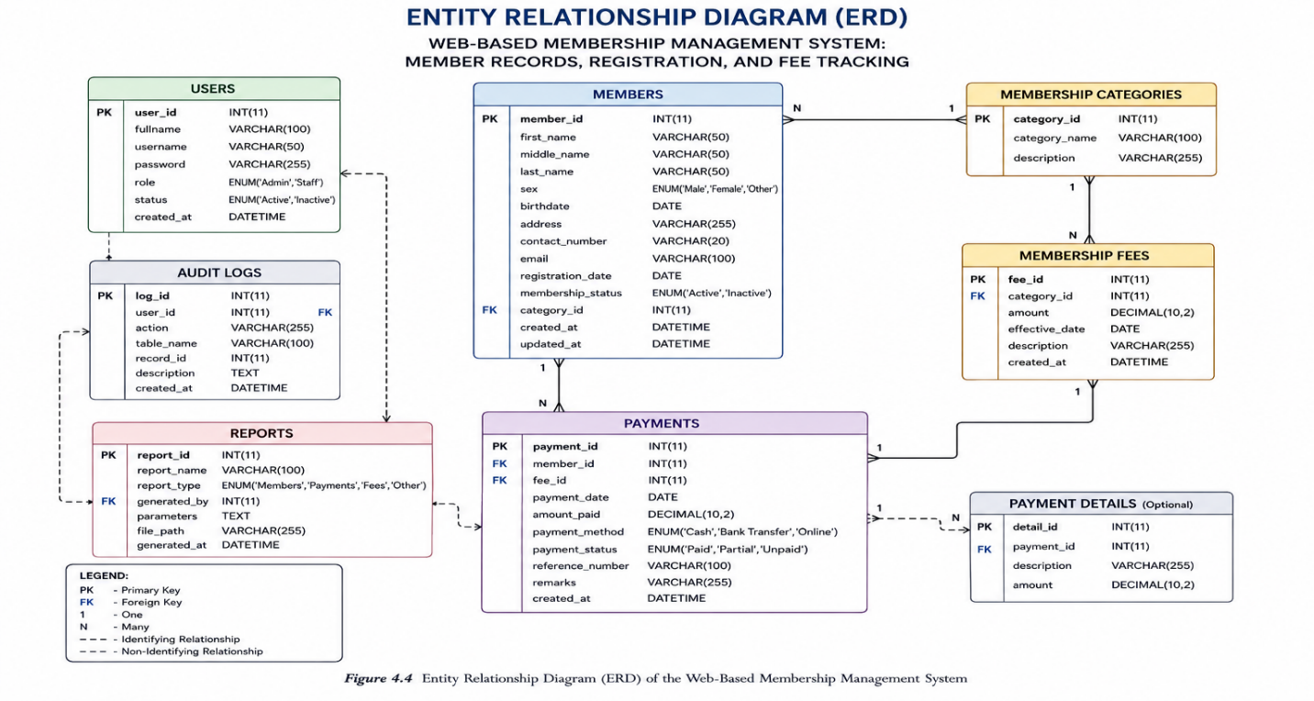
The primary entities included in the database are:
- Users
- Members
- Membership Categories
- Membership Fees
- Payments
These entities work together to support the various processes performed by the system. The relationships established among the tables enable efficient storage and retrieval of information while ensuring consistency throughout the database.

Users Table
The Users table stores the account credentials and profile information of individuals authorized to access the system. Each user is assigned a specific role, such as Administrator or Staff, which determines the level of access granted within the application.
Table 4.3 Users Table
Field | Description
user_id | Primary Key
fullname | Complete Name of the User
username | Login Username
password | Encrypted Password
role | User Access Level
status | Account Status
The information stored in this table is utilized during the authentication process to verify user identity before granting access to the system.

Members Table
The Members table contains the complete personal and membership information of every registered member within the organization. This table serves as the primary repository of member records maintained by the system.
Table 4.4 Members Table
Field | Description
member_id | Primary Key
first_name | Member's First Name
last_name | Member's Last Name
middle_name | Member's Middle Name
sex | Gender
birthdate | Date of Birth
address | Residential Address
contact_number | Contact Information
email | Email Address
registration_date | Date Registered
membership_status | Active or Inactive Membership
category_id | Foreign Key
This table allows administrators and staff to manage member records efficiently while maintaining accurate personal information for every registered member.

Membership Categories Table
The Membership Categories table stores the different membership classifications recognized by the organization. Each member is assigned to a specific category depending on the organization's policies.
Table 4.5 Membership Categories Table
Field | Description
category_id | Primary Key
category_name | Membership Category
description | Category Description
Using a separate table for membership categories minimizes redundancy and allows administrators to modify category information without affecting member records.

Membership Fees Table
The Membership Fees table stores the fee structure assigned to each membership category. It serves as the basis for determining the amount that members are required to pay.
Table 4.6 Membership Fees Table
Field | Description
fee_id | Primary Key
category_id | Foreign Key
amount | Membership Fee Amount
effective_date | Date Fee Becomes Effective
description | Fee Description
This table enables administrators to manage membership fees efficiently while ensuring that payment computations remain consistent across the system.

Payments Table
The Payments table records all membership fee payments made by registered members. Every payment transaction is linked to the corresponding member, allowing the system to maintain a complete payment history.
Table 4.7 Payments Table
Field | Description
payment_id | Primary Key
member_id | Foreign Key
fee_id | Foreign Key
payment_date | Date of Payment
amount_paid | Payment Amount
payment_status | Paid, Partial, or Unpaid
remarks | Additional Notes
The payment records maintained in this table enable the system to monitor membership fee collections, generate financial reports, and identify members with outstanding balances.

The relationships established among these database tables allow the developed application to efficiently process member registrations, maintain updated member records, record membership fee payments, and generate comprehensive organizational reports. Proper implementation of primary keys, foreign keys, indexing, and relational constraints ensures data integrity while improving query performance and minimizing redundancy.
Overall, the database design provides a secure, organized, and scalable foundation for the Web-Based Membership Management System. It supports efficient information management, reliable transaction processing, and accurate report generation, enabling the organization to perform membership management activities more effectively through a centralized database environment.

CHAPTER 5

CONCLUSION AND RECOMMENDATIONS

5.1 INTRODUCTION
This chapter presents the conclusion and recommendations of the study entitled Web-Based Membership Management System: Member Records, Registration, and Fee Tracking. It summarizes the significant findings obtained from the development, implementation, and evaluation of the system and determines whether the objectives of the study were successfully achieved. Furthermore, this chapter provides recommendations intended to enhance the developed application and improve its implementation for future use.
The development of the Web-Based Membership Management System was undertaken to address the challenges encountered in the organization's existing manual membership management procedures. These challenges included inefficient member registration, difficulty in maintaining accurate member records, delays in monitoring membership fee payments, and the time-consuming preparation of reports. By automating these essential processes, the developed system aimed to improve operational efficiency, increase data accuracy, strengthen record security, and facilitate faster access to organizational information.
Throughout the system development process, the researchers adopted the Agile Software Development Methodology to ensure continuous improvement and regular validation of system requirements. The developed application was designed with integrated modules for user authentication, member registration, member records management, membership fee tracking, payment recording, and report generation. These functionalities collectively provide a centralized platform capable of supporting the organization's daily administrative operations.
The evaluation of the developed system demonstrated that it successfully met the functional requirements identified during the requirements analysis phase. The application effectively automated the organization's membership management processes while reducing manual workloads and minimizing the occurrence of data entry errors. The centralized database further improved data organization by providing secure storage and efficient retrieval of membership information and payment records.

This chapter discusses the overall accomplishments of the study by presenting the summary of findings, drawing conclusions based on the research objectives, and providing practical recommendations that may further improve the developed system. It also highlights the contribution of the study to the organization and to future researchers who may develop similar information systems for membership management and organizational record keeping.

5.2 SUMMARY OF FINDINGS
The development of the Web-Based Membership Management System: Member Records, Registration, and Fee Tracking successfully achieved the objectives established at the beginning of the study. The developed application provided an effective solution to the problems encountered in the organization's manual membership management process by automating essential administrative tasks and centralizing organizational records into a secure database.
Based on the development, implementation, and evaluation of the system, the following findings were obtained:
- The developed system successfully automated the membership registration process by allowing authorized personnel to electronically register new members and securely store their information in a centralized database. This eliminated the need for manual record keeping, reduced processing time, and minimized data entry errors.
- The Member Records Management module effectively organized and maintained member information by providing functions for adding, updating, searching, viewing, and managing member records. The centralized database improved the accessibility, consistency, and accuracy of organizational information.
- The Membership Fee Tracking module efficiently recorded and monitored membership fee payments. The system maintained an updated payment history for every registered member, enabling administrators and staff to easily identify paid, partially paid, and unpaid membership fees while reducing errors associated with manual monitoring.
- The implemented user authentication and role-based access control mechanisms enhanced the security of the system by ensuring that only authorized users could access and manage organizational information. Different access privileges assigned to administrators and staff helped maintain data confidentiality and prevent unauthorized system operations.
- The report generation feature enabled users to produce accurate and timely reports regarding registered members, membership fee collections, payment histories, and other organizational records. These reports supported administrative monitoring and facilitated faster decision-making by providing organized and up-to-date information.
- The use of a relational MySQL database improved data management by maintaining the integrity of stored records through properly defined relationships among database tables. The centralized database reduced data redundancy while ensuring efficient retrieval and processing of membership information.
- The application was successfully developed using modern web technologies, including PHP, HTML, CSS, Bootstrap, JavaScript, and MySQL. The resulting system provided a responsive, user-friendly interface that allowed authorized users to perform their assigned tasks efficiently using a standard web browser.
Overall, the findings demonstrate that the Web-Based Membership Management System effectively addressed the identified problems associated with the organization's manual membership management procedures. The automation of registration, member record management, membership fee tracking, and report generation significantly improved operational efficiency while enhancing the accuracy, reliability, and security of organizational information.
Furthermore, the developed application demonstrated the practical use of web-based information systems in improving administrative processes within organizations. By providing a centralized and computerized membership management solution, the system contributes to more efficient record keeping, better financial monitoring, and improved organizational decision-making.

5.3 CONCLUSION
The Web-Based Membership Management System: Member Records, Registration, and Fee Tracking was successfully designed, developed, and implemented to address the challenges associated with the organization's manual membership management processes. The developed system achieved the primary objective of providing a centralized, secure, and efficient platform for managing member information, processing membership registrations, monitoring membership fee payments, and generating organizational reports.
The implementation of the system significantly improved the efficiency of membership management by replacing manual procedures with computerized processes. Through the automation of member registration, record management, and payment tracking, the system minimized human errors, reduced processing time, and improved the accuracy and consistency of organizational records. The centralized database further enhanced data accessibility by allowing authorized users to retrieve and update member information efficiently whenever necessary.
The incorporation of user authentication and role-based access control strengthened the security of the application by ensuring that only authorized personnel could access sensitive organizational information. Likewise, the report generation module enabled administrators and staff to obtain accurate and timely reports, thereby supporting effective monitoring of membership activities and informed decision-making.
The adoption of the Agile Software Development Methodology contributed to the successful completion of the project by allowing continuous collaboration, iterative development, and regular evaluation throughout the development process. This approach enabled the researchers to identify system requirements accurately, implement necessary improvements, and ensure that the developed application effectively addressed the operational needs of the organization.
Based on the overall findings of the study, it can be concluded that the Web-Based Membership Management System provides a practical and reliable solution for modernizing the organization's membership management processes. The developed application successfully fulfills the objectives of the study by improving operational efficiency, enhancing data accuracy, strengthening information security, and providing a more organized approach to managing membership records and membership fee transactions.
Furthermore, the study demonstrates the importance of utilizing web-based information systems in improving organizational operations. The implementation of the developed system illustrates how information technology can streamline administrative procedures, improve record management, and support better organizational decision-making. Consequently, the researchers conclude that the developed system is an effective, reliable, and sustainable solution that can contribute to the continuous improvement of membership management within the organization.

5.4 RECOMMENDATIONS
Based on the findings and conclusions of the study, the researchers recommend several improvements and implementation strategies to further enhance the effectiveness and long-term usability of the Web-Based Membership Management System: Member Records, Registration, and Fee Tracking. These recommendations are intended to assist the organization in maximizing the benefits of the developed system and to provide guidance for future researchers who may undertake similar projects.

System Improvements
To further improve the functionality and performance of the developed application, the following enhancements are recommended:
- Implement automated notification features that can send reminders to members regarding upcoming or overdue membership fee payments through email or SMS. This feature would improve payment compliance and reduce the need for manual follow-ups.
- Integrate online payment gateways to enable members to pay their membership fees electronically using various digital payment methods. This enhancement would provide greater convenience for both members and administrators.
- Strengthen system security by implementing additional security measures such as two-factor authentication (2FA), password encryption enhancements, account recovery mechanisms, and audit logs to further protect sensitive organizational information.

- Develop data backup and recovery features that automatically create scheduled backups of the database to minimize the risk of data loss caused by hardware failure, system errors, or unforeseen incidents.
- Expand the reporting module by providing additional filtering options, graphical summaries, and export capabilities that allow reports to be generated in PDF, Microsoft Excel, and CSV formats for easier documentation and record sharing.
- Enhance the user interface by incorporating additional accessibility features and improving the responsiveness of the application across different screen sizes and devices to provide a better user experience.

Future Research Directions
Future researchers may further improve the developed system by considering the following enhancements:
- Develop a mobile application version of the system to allow administrators, staff, and authorized users to access membership information using smartphones and tablets.
- Integrate QR Code or Barcode technology to facilitate faster member identification, attendance monitoring, or payment verification during organizational activities.
- Incorporate data analytics and visualization tools that provide statistical summaries and graphical representations of membership growth, payment trends, and organizational performance to support strategic planning.
- Conduct additional studies involving larger organizations or multiple branches to evaluate the scalability, performance, and adaptability of the developed application in different operational environments.
- Explore the integration of cloud-based technologies to provide secure remote access, centralized data storage, and real-time synchronization of membership information across multiple locations.

Implementation Strategies
To ensure the successful adoption and continuous operation of the Web-Based Membership Management System, the following implementation strategies are recommended:
- The organization should provide orientation and training sessions for administrators and staff members before the full implementation of the system to ensure that users understand all system functions and operational procedures.
- Regular database maintenance and system backups should be performed to preserve data integrity, improve system performance, and prevent information loss.
- System administrators should periodically update user accounts, passwords, and access privileges to maintain the security of confidential organizational information.
- Routine software updates and security patches should be applied whenever necessary to protect the application from vulnerabilities and maintain compatibility with current technologies.
- The organization should establish clear policies regarding data entry, membership registration, and payment recording to ensure that all information entered into the system remains accurate, complete, and consistent.
By implementing these recommendations, the organization can further improve the efficiency, reliability, and sustainability of the Web-Based Membership Management System. Continuous enhancement of the application will enable the system to adapt to future organizational requirements while supporting effective membership management, secure information processing, and improved administrative decision-making.

5.5 IMPACT OF THE STUDY
The development of the Web-Based Membership Management System: Member Records, Registration, and Fee Tracking contributes to the advancement of information technology by demonstrating the practical application of a web-based information system in improving organizational membership management. The study highlights how digital solutions can replace traditional manual procedures, resulting in more efficient administrative operations, improved data accuracy, and enhanced information security.
For the organization, the implementation of the developed system provides a centralized platform for managing member records, processing membership registrations, monitoring membership fee payments, and generating reports. By automating these essential processes, the system minimizes manual workloads, reduces the occurrence of human errors, and enables authorized personnel to access accurate and updated information more efficiently. Consequently, the organization can improve its overall productivity and provide better services to its members.

The developed system also benefits administrators and staff members by simplifying routine administrative tasks. The availability of organized member records, automated payment monitoring, and comprehensive reporting allows users to perform their responsibilities more effectively while reducing the time required to complete daily operations. Furthermore, the implementation of user authentication and role-based access control strengthens the protection of confidential organizational information by limiting access to authorized personnel only.
From an academic perspective, this study contributes to the field of information systems by serving as a reference for future researchers and students who intend to develop similar web-based management applications. The methodologies, database design, system architecture, and

development processes presented in this study may provide valuable guidance for future software development projects involving organizational information management.
The study also demonstrates the importance of adopting modern software engineering principles and web technologies in addressing real-world organizational challenges. Through the use of Agile Software Development Methodology, responsive web technologies, and relational database management systems, the researchers successfully developed a reliable and maintainable application capable of supporting the organization's operational requirements.
Although the developed system effectively addressed the objectives of the study, certain limitations remain. The application was designed specifically to meet the requirements of the participating organization and may require additional customization before implementation in organizations with different operational policies or membership structures. Future enhancements, including mobile application support, online payment integration, cloud deployment, automated notifications, and advanced analytics, may further increase the capabilities and usability of the system.
Overall, the Web-Based Membership Management System demonstrates the significant role of information technology in modernizing organizational processes. The study confirms that implementing a computerized membership management system improves operational efficiency, enhances data management, strengthens information security, and supports informed decision-making. As organizations continue to embrace digital transformation, systems such as the one developed in this study can serve as effective tools for improving administrative performance and organizational productivity.

5.6 SUMMARY
This chapter presented the conclusions and recommendations of the study entitled Web-Based Membership Management System: Member Records, Registration, and Fee Tracking. It summarized the significant findings obtained during the development, implementation, and evaluation of the system and assessed whether the objectives of the study were successfully achieved.
The findings demonstrated that the developed system effectively automated the organization's membership management processes by providing efficient member registration, centralized member record management, accurate membership fee tracking, secure user authentication, and comprehensive report generation. These functionalities contributed to improved operational efficiency, enhanced data accuracy, reduced manual workloads, and strengthened the security of organizational information.
The study concluded that the implementation of the Web-Based Membership Management System provides a practical, reliable, and sustainable solution for modernizing the organization's membership management operations. By replacing manual procedures with a computerized information system, the organization can perform administrative tasks more efficiently while maintaining accurate and organized records.
Furthermore, the recommendations presented in this chapter highlighted several opportunities for future system enhancement, including the integration of online payment facilities, mobile application support, automated notifications, cloud-based deployment, advanced reporting features, and strengthened security mechanisms. These improvements may further increase the effectiveness, usability, and scalability of the developed application.
Overall, the study demonstrates the value of applying web-based information systems and modern software engineering principles to organizational management. The developed Web-Based Membership Management System not only addressed the identified problems encountered in the existing manual process but also provided a foundation for continuous improvement and future technological advancement. The researchers believe that the system can significantly contribute to more efficient membership management, better decision-making, and improved organizational productivity while serving as a valuable reference for future researchers undertaking similar system development projects.

